**Practical No 6**

**a) Create a web application for inserting and deleting records from a database.**

**Registration Form :**

**aspx code :**

<%@ Page Language="C#" AutoEventWireup="true" CodeBehind="WebForm1.aspx.cs" Inherits="pract6b_DisconnectedArch.WebForm1" %>

<!DOCTYPE html>

<html xmlns="http://www.w3.org/1999/xhtml">

<head runat="server">

<title></title>

</head>

<body>

<form id="form1" runat="server">

<div class="auto-style1">

<br />

<asp:Label ID="Label1" runat="server" CssClass="auto-style3" Text="Name"></asp:Label>

<asp:Label ID="Label2" runat="server" CssClass="auto-style5" Text="City"></asp:Label>

<asp:Label ID="Label3" runat="server" CssClass="auto-style4" Text="Age"></asp:Label>

<br />

<br />

<br />

<br />

</div>

<asp:TextBox ID="TextBox1" runat="server" CssClass="auto-style6"></asp:TextBox>

<asp:TextBox ID="TextBox2" runat="server" CssClass="auto-style7"></asp:TextBox>

<asp:TextBox ID="TextBox3" runat="server" CssClass="auto-style8"></asp:TextBox>

<asp:Button ID="Button1" runat="server" CssClass="auto-style9" OnClick="Button1_Click" Text="Submit" />

<asp:GridView ID="GridView1" runat="server" AutoGenerateColumns="False" CssClass="auto-style11" DataKeyNames="Id">

<Columns>

<asp:BoundField DataField="Id" HeaderText="Id" InsertVisible="False" ReadOnly="True" SortExpression="Id" />

<asp:BoundField DataField="Name" HeaderText="Name" SortExpression="Name" />

<asp:BoundField DataField="Age" HeaderText="Age" SortExpression="Age" />

<asp:BoundField DataField="City" HeaderText="City" SortExpression="City" />

</Columns>

</asp:GridView>

<asp:SqlDataSource ID="SqlDataSource3" runat="server" ConnectionString="<%$ ConnectionStrings:ConnectionString %>" SelectCommand="SELECT * FROM [userData]"></asp:SqlDataSource>

<asp:Label ID="Label5" runat="server" CssClass="auto-style12"></asp:Label>

<asp:Button ID="Button2" runat="server" CssClass="auto-style13" OnClick="Button2_Click" Text="Delete" />

<asp:Label ID="Label4" runat="server" CssClass="auto-style10" Font-Bold="True" Font-Size="X-Large" Text="Registration Form"></asp:Label>

<p>

<asp:TextBox ID="TextBox4" runat="server" CssClass="auto-style14" OnTextChanged="TextBox4_TextChanged"> Enter Id</asp:TextBox>

</p>

</form>

</body>

</html>

**c# code :**

using System;

using System.Collections.Generic;

using System.Linq;

using System.Web;

using System.Web.UI;

using System.Web.UI.WebControls;

using System.Data;

using System.Data.SqlClient;

namespace pract6b_DisconnectedArch

{

public partial class WebForm1 : System.Web.UI.Page

{

SqlConnection con = new SqlConnection(@"Data Source=(LocalDB)\MSSQLLocalDB;AttachDbFilename=C:\Users\tkrmm\source\repos\pract6b_DisconnectedArch\App_Data\Database1.mdf;Integrated Security=True");

protected void Page_Load(object sender, EventArgs e)

{

SqlDataAdapter da = new SqlDataAdapter("select * from userData", con);

DataSet ds = new DataSet();

da.Fill(ds);

GridView1.DataSource = ds;

GridView1.DataBind();

}

protected void Button1_Click(object sender, EventArgs e)

{

SqlDataAdapter da = new SqlDataAdapter("select * from userData", con);

SqlCommandBuilder cb = new SqlCommandBuilder(da);

cb.GetInsertCommand();

DataTable dt = new DataTable("userData");

da.Fill(dt);

DataRow dr = dt.NewRow();

dr["Name"] = TextBox1.Text;

dr["Age"] = Convert.ToInt32(TextBox2.Text);

dr["City"] = TextBox3.Text;

dt.Rows.Add(dr);

da.Update(dt);

Label5.Text = "Record Inserted Successfully!!";

GridView1.DataSource = dt;

GridView1.DataBind();

}

protected void Button2_Click(object sender, EventArgs e)

{

SqlDataAdapter da = new SqlDataAdapter("select * from userData", con);

SqlCommandBuilder cb = new SqlCommandBuilder(da);

cb.GetDeleteCommand();

DataTable dt = new DataTable("userData");

da.Fill(dt);

DataRow[] dr = dt.Select("Id="+Convert.ToInt32(TextBox4.Text));

dr[0].Delete();

da.Update(dt);

Label5.Text = "Record Deleted Successfully!!";

GridView1.DataSource = dt;

GridView1.DataBind();

}

}

}

**Output:**

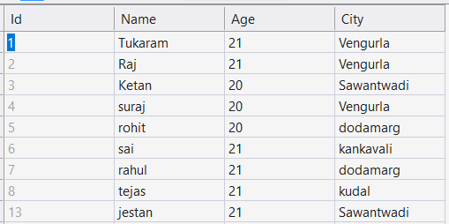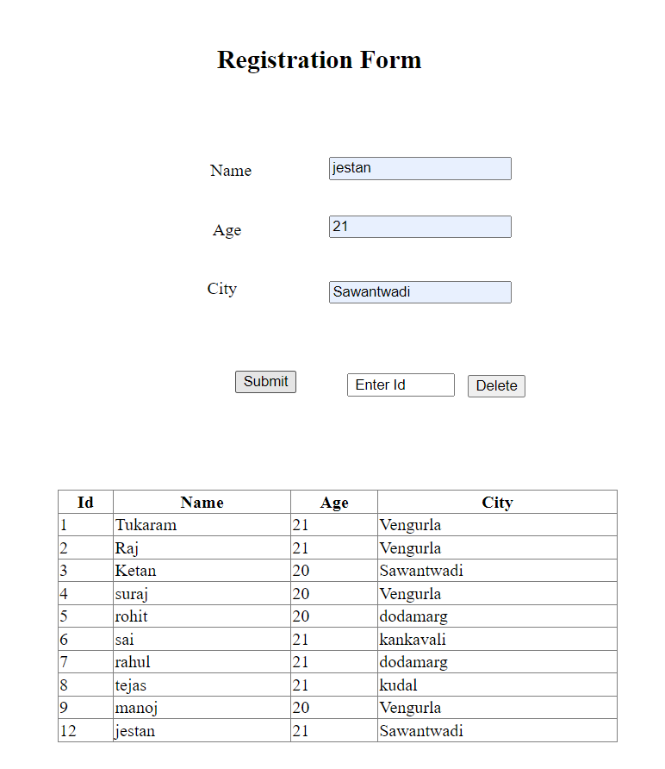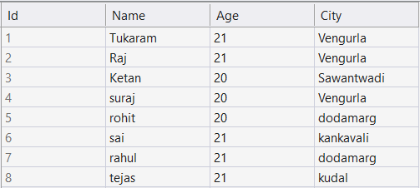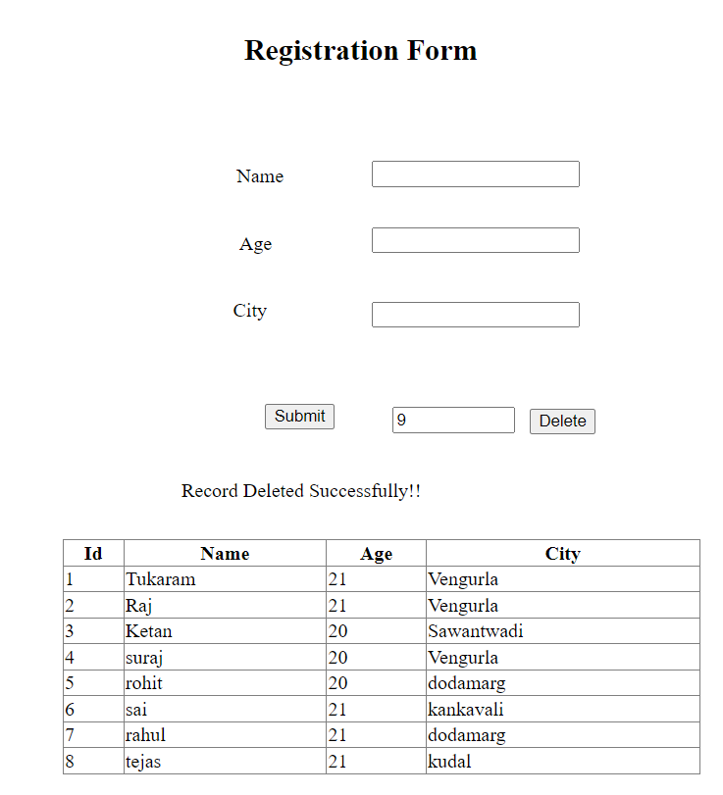**Insertion: Deletion:**

Record Inserted Successfully!!

**b) Create a web application to display Using Disconnected Data Access and Databinding using GridView.**

**Registration Form:**

**aspx code :**

<%@ Page Language="C#" AutoEventWireup="true" CodeBehind="WebForm1.aspx.cs" Inherits="pract6b_DisconnectedArch.WebForm1" %>

<!DOCTYPE html>

<html xmlns="http://www.w3.org/1999/xhtml">

<head runat="server">

<title></title>

</head>

<body>

<form id="form1" runat="server">

<div class="auto-style1">

<br />

<asp:Label ID="Label1" runat="server" CssClass="auto-style3" Text="Name"></asp:Label>

<asp:Label ID="Label2" runat="server" CssClass="auto-style5" Text="City"></asp:Label>

<asp:Label ID="Label3" runat="server" CssClass="auto-style4" Text="Age"></asp:Label>

<br />

<br />

<br />

<br />

</div>

<asp:TextBox ID="TextBox1" runat="server" CssClass="auto-style6"></asp:TextBox>

<asp:TextBox ID="TextBox2" runat="server" CssClass="auto-style7"></asp:TextBox>

<asp:TextBox ID="TextBox3" runat="server" CssClass="auto-style8"></asp:TextBox>

<asp:Button ID="Button1" runat="server" CssClass="auto-style9" OnClick="Button1_Click" Text="Submit" />

<asp:GridView ID="GridView1" runat="server" AutoGenerateColumns="False" CssClass="auto-style11" DataKeyNames="Id">

<Columns>

<asp:BoundField DataField="Id" HeaderText="Id" InsertVisible="False" ReadOnly="True" SortExpression="Id" />

<asp:BoundField DataField="Name" HeaderText="Name" SortExpression="Name" />

<asp:BoundField DataField="Age" HeaderText="Age" SortExpression="Age" />

<asp:BoundField DataField="City" HeaderText="City" SortExpression="City" />

</Columns>

</asp:GridView>

<asp:SqlDataSource ID="SqlDataSource3" runat="server" ConnectionString="<%$ ConnectionStrings:ConnectionString %>" SelectCommand="SELECT * FROM [userData]"></asp:SqlDataSource>

<asp:Label ID="Label5" runat="server" CssClass="auto-style12"></asp:Label>

<asp:Button ID="Button2" runat="server" CssClass="auto-style13" OnClick="Button2_Click" Text="Delete" />

<asp:Label ID="Label4" runat="server" CssClass="auto-style10" Font-Bold="True" Font-Size="X-Large" Text="Registration Form"></asp:Label>

<p>

<asp:TextBox ID="TextBox4" runat="server" CssClass="auto-style14" OnTextChanged="TextBox4_TextChanged"> Enter Id</asp:TextBox>

</p>

</form>

</body>

</html>

**c# code :**

using System;

using System.Collections.Generic;

using System.Linq;

using System.Web;

using System.Web.UI;

using System.Web.UI.WebControls;

using System.Data;

using System.Data.SqlClient;

namespace pract6b_DisconnectedArch

{

public partial class WebForm1 : System.Web.UI.Page

{

SqlConnection con = new SqlConnection(@"Data Source=(LocalDB)\MSSQLLocalDB;AttachDbFilename=C:\Users\tkrmm\source\repos\pract6b_DisconnectedArch\App_Data\Database1.mdf;Integrated Security=True");

protected void Page_Load(object sender, EventArgs e)

{

SqlDataAdapter da = new SqlDataAdapter("select * from userData", con);

DataSet ds = new DataSet();

da.Fill(ds);

GridView1.DataSource = ds;

GridView1.DataBind();

}

protected void Button1_Click(object sender, EventArgs e)

{

SqlDataAdapter da = new SqlDataAdapter("select * from userData", con);

SqlCommandBuilder cb = new SqlCommandBuilder(da);

cb.GetInsertCommand();

DataTable dt = new DataTable("userData");

da.Fill(dt);

DataRow dr = dt.NewRow();

dr["Name"] = TextBox1.Text;

dr["Age"] = Convert.ToInt32(TextBox2.Text);

dr["City"] = TextBox3.Text;

dt.Rows.Add(dr);

da.Update(dt);

Label5.Text = "Record Inserted Successfully!!";

GridView1.DataSource = dt;

GridView1.DataBind();

}

protected void Button2_Click(object sender, EventArgs e)

{

SqlDataAdapter da = new SqlDataAdapter("select * from userData", con);

SqlCommandBuilder cb = new SqlCommandBuilder(da);

cb.GetDeleteCommand();

DataTable dt = new DataTable("userData");

da.Fill(dt);

DataRow[] dr = dt.Select("Id="+Convert.ToInt32(TextBox4.Text));

dr[0].Delete();

da.Update(dt);

Label5.Text = "Record Deleted Successfully!!";

GridView1.DataSource = dt;

GridView1.DataBind();

}

}

}

**Output:**

**Insertion: Deletion:**

Record Inserted Successfully!!

* **Create a web application for inserting and deleting records from a database.**

**aspx code :**

<%@ Page Language="C#" AutoEventWireup="true" CodeBehind="CreditRemaining.aspx.cs" Inherits="project2.CreditRemaining" %>

<!DOCTYPE html>

<html xmlns="http://www.w3.org/1999/xhtml">

<head runat="server">

<title></title>

<link rel="stylesheet" type="text/css" href="Home.css" />

<link rel="stylesheet" type="text/css" href="home22.css" />

<style type="text/css">

.auto-style2 {

background-color: #f7ab9c;

border-radius: 8px;

border-color : #fc0303;

color: white;

hight: 30px;

width: 294px;

z-index: 1;

position: absolute;

top: 130px;

left: 596px;

height: 33px;

}

.auto-style3 {

background-color: #f7ab9c;

border-radius: 8px;

border-color : #fc0303;

color: white;

hight: 30px;

width: 295px;

z-index: 1;

position: absolute;

top: 73px;

left: 596px;

height: 34px;

}

.auto-style4 {

background-color: #f7ab9c;

border-radius: 8px;

border-color : #fc0303;

color: white;

hight: 30px;

width: 294px;

z-index: 1;

position: absolute;

top: 183px;

left: 597px;

height: 35px;

}

.auto-style5 {

border-radius: 8px;

z-index: 1;

position: absolute;

top: 4px;

left: 388px;

width: 428px;

}

.auto-style6 {

position: absolute;

top: 132px;

left: 539px;

z-index: 1;

}

.auto-style7 {

position: absolute;

top: 81px;

left: 917px;

z-index: 1;

width: 215px;

}

.auto-style8 {

position: absolute;

top: 139px;

left: 918px;

z-index: 1;

width: 185px;

}

.auto-style9 {

position: absolute;

top: 194px;

left: 917px;

z-index: 1;

width: 161px;

}

.auto-style10 {

color: white;

background-color: #077003;

border-radius: 8px;

border-style: solid;

border-color: red;

z-index: 1;

position: absolute;

top: 325px;

left: 627px;

}

.auto-style11 {

background-color: #98d1fa;

border-style: solid;

border-color: black;

border-radius: 8px;

z-index: 1;

position: absolute;

top: 424px;

left: 316px;

width: 555px;

height: 253px;

}

</style>

</head>

<body>

<form id="form1" runat="server">

<div id="navbar">

<nav class="navbar">

<ul>

<li><a href="Home.aspx">Home</a></li>

<li><a href="Calculator.aspx">Calculator</a></li>

<li><a href="CalculationRecords.aspx">Calculation Records</a></li>

<li><a href="Calender.aspx">Calender</a></li>

<li><a href="CreditRemaining.aspx">Credit Remaining</a></li>

<li><a href="AllCashEntry.aspx">All Cash Entry</a></li>

</ul>

</nav>

</div>

<asp:TextBox ID="TextBox3" runat="server" CssClass="auto-style4" Font-Bold="True" Font-Size="X-Large" ForeColor="Black"></asp:TextBox>

<asp:Label ID="Label1" runat="server" CssClass="auto-style5" Font-Bold="True" Font-Names="Times New Roman" Font-Overline="False" Font-Size="XX-Large" ForeColor="White" Text="Creadit reegistration window" BorderColor="White" BorderStyle="Solid"></asp:Label>

<asp:TextBox ID="TextBox2" runat="server" CssClass="auto-style2" Font-Bold="True" Font-Size="X-Large" ForeColor="Black"></asp:TextBox>

<asp:Label ID="Label2" runat="server" CssClass="LabelCss" Font-Bold="True" Font-Size="X-Large" ForeColor="White" Text="Enter Customer Name : " style="z-index: 1; position: absolute; top: 84px; left: 283px"></asp:Label>

<asp:Label ID="Label3" runat="server" CssClass="LabelCss" Font-Bold="True" Font-Size="X-Large" ForeColor="White" Text="Enter the Amount : " style="z-index: 1; position: absolute; top: 183px; left: 328px"></asp:Label>

<asp:Label ID="Label5" runat="server" CssClass="auto-style6" Font-Bold="True" Font-Size="X-Large" ForeColor="White" Text=":"></asp:Label>

<asp:Label ID="Label4" runat="server" CssClass="LabelCss" Font-Bold="True" Font-Size="X-Large" ForeColor="White" Text=" Creadit Name " style="z-index: 1; position: absolute; top: 129px; left: 369px; width: 164px"></asp:Label>

<asp:Button ID="Button1" runat="server" CssClass="ButtonCss" Font-Bold="True" Font-Size="X-Large" Text="insert credit" OnClick="Button1_Click" style="z-index: 1; position: absolute; top: 249px; left: 287px; width: 294px" />

<asp:TextBox ID="TextBox1" runat="server" CssClass="auto-style3" Font-Bold="True" Font-Size="X-Large" ForeColor="Black"></asp:TextBox>

<asp:Button ID="Button2" runat="server" CssClass="ButtonCss" Font-Bold="True" Font-Size="X-Large" Text="retrive credit" OnClick="Button2_Click" style="z-index: 1; position: absolute; top: 249px; left: 632px; width: 337px" CausesValidation="False" />

<asp:TextBox ID="TextArea1" runat="server" CssClass="auto-style11" TextMode="MultiLine" Rows="15" Columns="50" ReadOnly="True" Font-Bold="True" Font-Size="X-Large" ForeColor="Black"></asp:TextBox>

<asp:DropDownList ID="DropDownList1" runat="server" CssClass="ddlcss" DataTextField="c_Name" DataValueField="Id" style="z-index: 1; position: absolute; top: 331px; left: 309px; width: 169px; height: 45px" Font-Bold="True" Font-Size="X-Large" >

</asp:DropDownList>

<asp:Button ID="Button3" runat="server" CssClass="auto-style10" Font-Bold="True" Font-Size="X-Large" Text="delete selected credit" OnClick="Button3_Click" CausesValidation="False" />

<asp:SqlDataSource ID="SqlDataSource1" runat="server" ConnectionString="<%$ ConnectionStrings:ConnectionString %>" SelectCommand="SELECT * FROM [CreaditRecords]"></asp:SqlDataSource>

<asp:RequiredFieldValidator ID="RequiredFieldValidator3" runat="server" ControlToValidate="TextBox3" CssClass="auto-style9" ErrorMessage="pls fill this field" Font-Bold="True" Font-Size="Large" ForeColor="Red"></asp:RequiredFieldValidator>

<asp:RequiredFieldValidator ID="RequiredFieldValidator2" runat="server" ControlToValidate="TextBox2" CssClass="auto-style8" ErrorMessage="pls fill this field" Font-Bold="True" Font-Size="Large" ForeColor="Red"></asp:RequiredFieldValidator>

<asp:RequiredFieldValidator ID="RequiredFieldValidator1" runat="server" CssClass="auto-style7" ErrorMessage="pls fill this field" Font-Bold="True" Font-Size="Large" ForeColor="Red" ControlToValidate="TextBox1"></asp:RequiredFieldValidator>

</form>

</body>

</html>

**c# code :**

using System;

using System.Collections.Generic;

using System.Linq;

using System.Web;

using System.Web.UI;

using System.Web.UI.WebControls;

using System.Data.SqlClient;

using System.Configuration;

using System.Data;

using System.Text;

namespace project2

{

public partial class CreditRemaining : System.Web.UI.Page

{

SqlConnection con = new SqlConnection(ConfigurationManager.ConnectionStrings["ConnectionString"].ConnectionString);

protected void Page_Load(object sender, EventArgs e)

{

con.Open();

if(!IsPostBack)

{

DDLNameLoad();

}

}

protected void Button1_Click(object sender, EventArgs e)

{

SqlCommand cmd = new SqlCommand("insert into CreaditRecords values('" + TextBox1.Text + "','" + TextBox2.Text + "','" + TextBox3.Text + "')", con);

cmd.ExecuteNonQuery();

TextBox1.Text = "";

TextBox2.Text = "";

TextBox3.Text = "";

DDLNameLoad();

}

void TotalIncome()

{

string selectedName = DropDownList1.SelectedValue;

SqlCommand cmd4 = new SqlCommand("select Amount from CreaditRecords where Name=@Name", con);

cmd4.Parameters.AddWithValue("@Name", selectedName);

cmd4.ExecuteNonQuery();

object amount = cmd4.ExecuteScalar();

if(amount!=null)

{

int num = Convert.ToInt16(amount);

SqlCommand cmd5=new SqlCommand("insert into Income_Table1 (income_amount) values(@income_Amount)",con);

cmd5.Parameters.AddWithValue("@income_amount", num);

cmd5.ExecuteNonQuery();

}

}

protected void Button2_Click(object sender, EventArgs e)

{

SqlCommand cmd1 = new SqlCommand("select * from CreaditRecords", con);

SqlDataReader reader = cmd1.ExecuteReader();

StringBuilder resultBuilder = new StringBuilder();

while (reader.Read())

{

resultBuilder.AppendLine($"customer ID: {reader["id"]}");

resultBuilder.AppendLine($"customer Name: {reader["Name"]}");

resultBuilder.AppendLine($"Credit Name: {reader["C_Name"]}");

resultBuilder.AppendLine($"Creadit Amount: {reader["Amount"]}");

resultBuilder.AppendLine();

resultBuilder.AppendLine();

}

TextArea1.Text = resultBuilder.ToString();

reader.Close();

}

void DDLNameLoad()

{

SqlCommand cmd = new SqlCommand("select Name from CreaditRecords", con);

SqlDataAdapter sda = new SqlDataAdapter(cmd);

//SqlCommandBuilder cmb = new SqlCommandBuilder(sda);

DataTable dt = new DataTable();

sda.Fill(dt);

DropDownList1.DataSource = dt;

DropDownList1.DataValueField = "Name";

DropDownList1.DataTextField = "Name";

DropDownList1.DataBind();

}

protected void Button3_Click(object sender, EventArgs e)

{

string selectedName = DropDownList1.SelectedValue;

SqlCommand cmd3 = new SqlCommand("delete from CreaditRecords where Name=@Name", con);

cmd3.Parameters.AddWithValue("@Name", selectedName);

TotalIncome();

int rowaffected = cmd3.ExecuteNonQuery();

if (rowaffected > 0)

{

DDLNameLoad();

}

con.Close();

}

}

}

**OUTPUT 1 : for insert and retrive the data .**

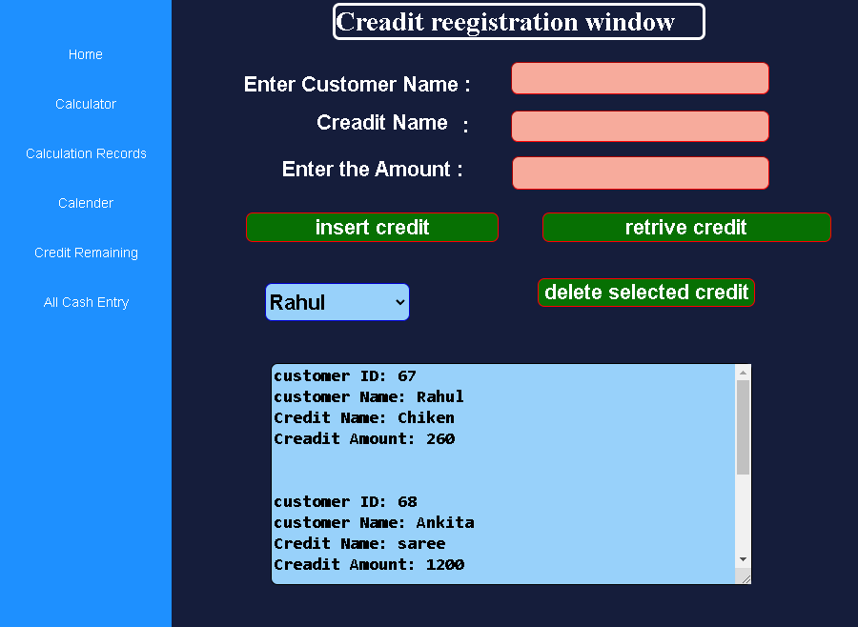

**OUTPUT 2: delete the data from the dropdownlist.**



